SQL-запросы
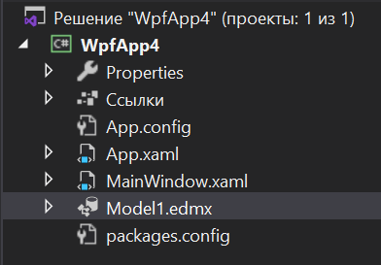
XAML
<Window x:Class="WpfApp4.MainWindow"
xmlns="http://schemas.microsoft.com/winfx/2006/xaml/presentation"
xmlns:x="http://schemas.microsoft.com/winfx/2006/xaml"
xmlns:d="http://schemas.microsoft.com/expression/blend/2008"
xmlns:mc="http://schemas.openxmlformats.org/markup-compatibility/2006"
xmlns:local="clr-namespace:WpfApp4"
mc:Ignorable="d"
Title="MainWindow" Height="450" Width="800">
<Grid>

<Grid.RowDefinitions>
<RowDefinition/>
<RowDefinition Height="30"/>
</Grid.RowDefinitions>

<DataGrid x:Name="mainGrid"/>
<StackPanel Grid.Row="1" Orientation="Horizontal">
<Button Content="Добавить" Click="ButtonClick"/>
<TextBox Width="150" x:Name="MyTextBox"/>
<Button Content="Удалить" Click="DeleteButtonClick"/>
</StackPanel>
</Grid>
</Window>

CS
namespace WpfApp4
{
/// <summary>
/// Interaction logic for MainWindow.xaml
/// </summary>
public partial class MainWindow : Window
{
LibraryExEntities MyBase = new LibraryExEntities();

public MainWindow()
{
InitializeComponent();
mainGrid.ItemsSource = MyBase.Publishers.SqlQuery("select * from Publishers").ToList();
}

private void ButtonClick(object sender, RoutedEventArgs e)
{
//с передачей входных параметров
var text = MyTextBox.Text;
MyBase.Database.ExecuteSqlCommand($"insert into Publishers(PublisherName) values('{text}')");
mainGrid.ItemsSource = MyBase.Publishers.SqlQuery("select * from Publishers").ToList();
}

private void DeleteButtonClick(object sender, RoutedEventArgs e)
{
var id = ((Publishers)mainGrid.SelectedItem).IdPublisher;
MyBase.Database.ExecuteSqlCommand($"delete from Publishers where IdPublisher = {id}");
mainGrid.ItemsSource = MyBase.Publishers.SqlQuery("select * from Publishers").ToList();

List<Publishers> vs = (List<Publishers>)mainGrid.ItemsSource;
}
}
}

